***PRACTICAL 5***

***STORED PROCEDURES***

**1. Write a PL/SQL program of stored procedures to print 'Welcome to stored procedures'.**

**Code:**

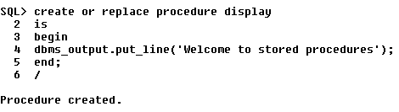

**Output:**

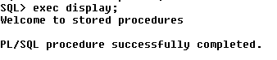

**2. Write a PL/SQL program of stored procedures to add two numbers.**

**Code:**

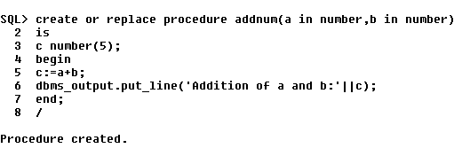

**Output:**

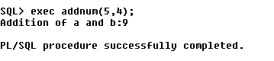

**3. Write a PL/SQL program of stored procedures to accept employee id and display employee name.**

**Code:**

**i) create table employee and insert values into it.**

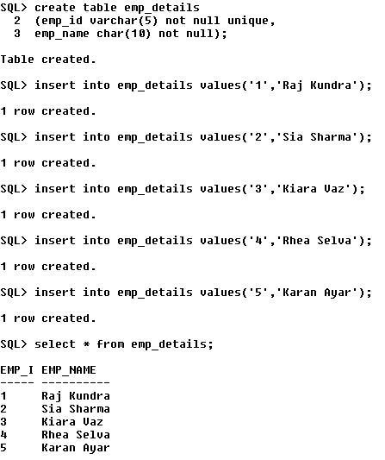

**ii) create procedure disp_emp_name**

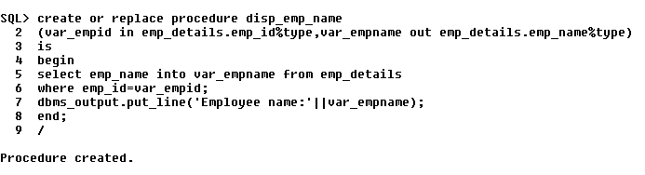

**iii) call procedure from a pl/sql program.**

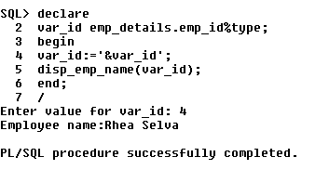

**4. Write a procedure sal_increase it should behave as follows:**

**a) if salary is in between 10000 and 20000 increment 12%**

**b) if salary is in between 20000 and 30000 increment 15%**

**c) if salary is greater than 30000 increment by 20%**

**Accept emp_id from user and do the increment for the employee.**

**Consider table schema as follows:**

**emp(emp_id,emp_sal)**

**Code:**

**i) create table emp_sal and insert values into it.**

**create table emp_sal**

**(emp_id varchar(5) not null unique,**

**emp_salary number(10) not null);**

**insert into emp_sal values('1',11000);**

**insert into emp_sal values('2',25000);**

**insert into emp_sal values('3',31000);**

**insert into emp_sal values('4',17000);**

**insert into emp_sal values('5',28000);**

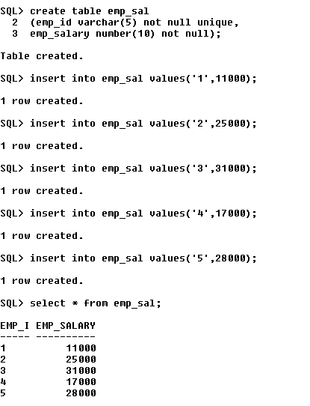

**ii) create procedure update_emp_sal**

**create or replace procedure update_emp_sal**

**(var_emp_id in emp_sal.emp_id%type)**

**is**

**var_emp_salary emp_sal.emp_salary%type;**

**var number(8,2);**

**begin**

**select emp_salary into var_emp_salary from emp_sal**

**where emp_id=var_emp_id;**

**if(var_emp_salary>10000 and var_emp_salary<=20000) then**

**var:=var_emp_salary+((12*var_emp_salary)/100);**

**update emp_sal set emp_salary=var where emp_id=var_emp_id;**

**elsif(var_emp_salary>20000 and var_emp_salary<=30000) then**

**var:=var_emp_salary+((15*var_emp_salary)/100);**

**update emp_sal set emp_salary=var where emp_id=var_emp_id;**

**elsif(var_emp_salary>30000) then**

**var:=var_emp_salary+((20*var_emp_salary)/100);**

**update emp_sal set emp_salary=var where emp_id=var_emp_id;**

**end if;**

**end;**

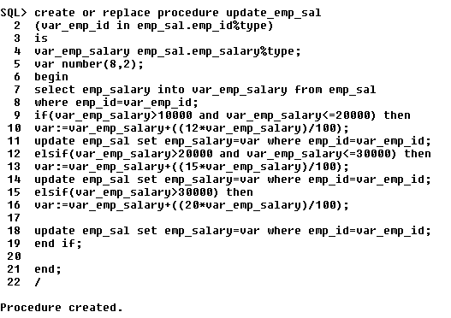

**iii) call procedure from a pl/sql program.**

**declare**

**var_id number(3);**

**begin**

**var_id:=&var_id;**

**update_emp_sal(var_id);**

**dbms_output.put_line('Salary incremented successfully');**

**end;**

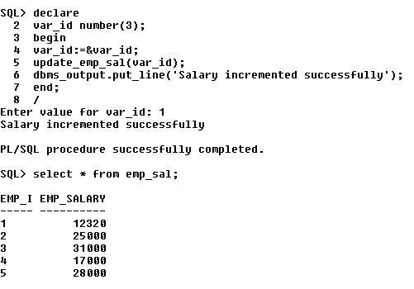

**5. Write a procedure to calculate area of triangle, rectangle and square.**

**Depends on users choice with case where it displays the respective area values.**